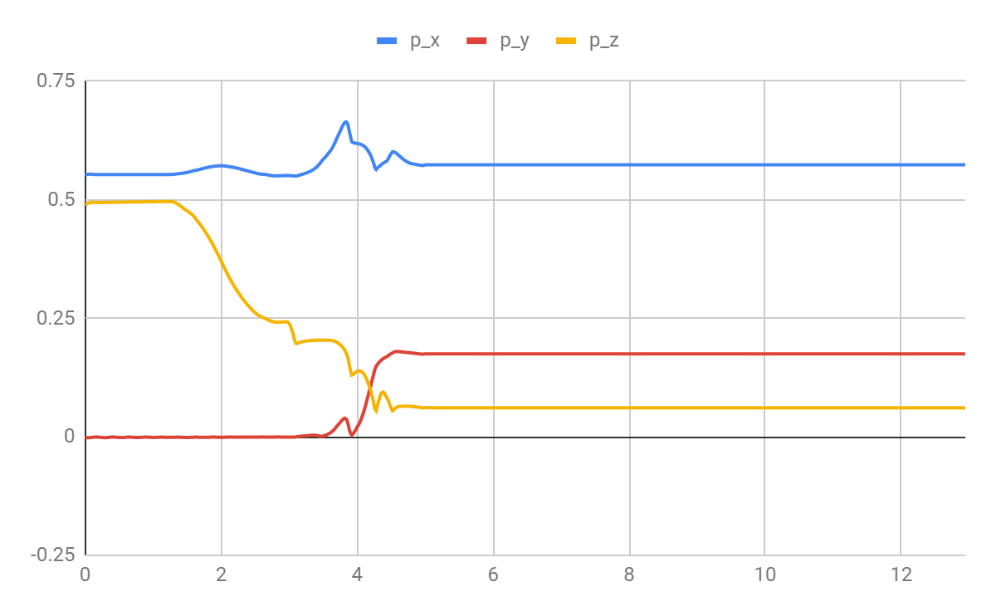**POSITION V/S TIME FOR IDEAL ROBOT**

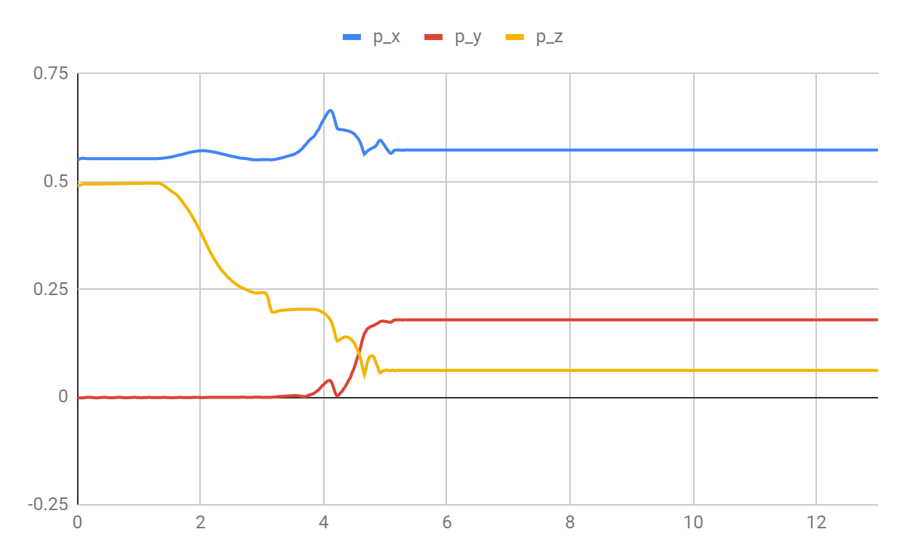

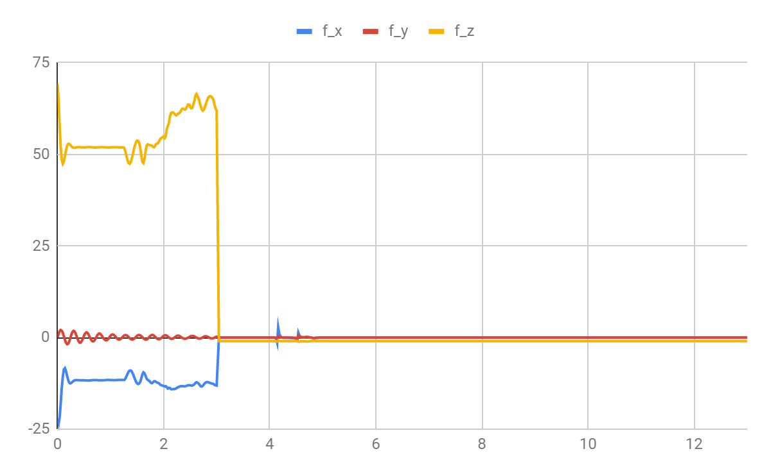**FORCE V/S TIME FOR IDEAL ROBOT**

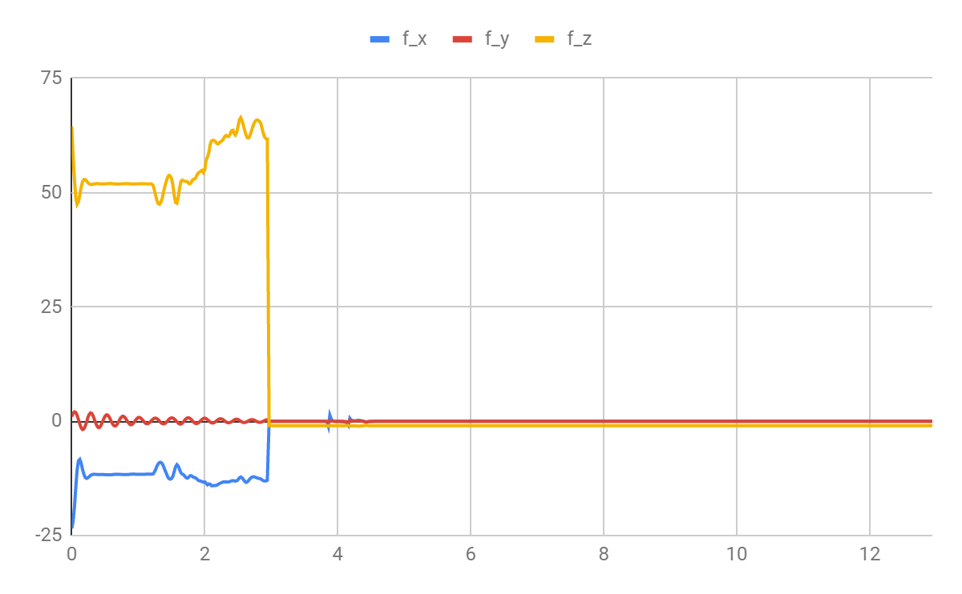

**POSITION V/S TIME FOR REAL ROBOT**

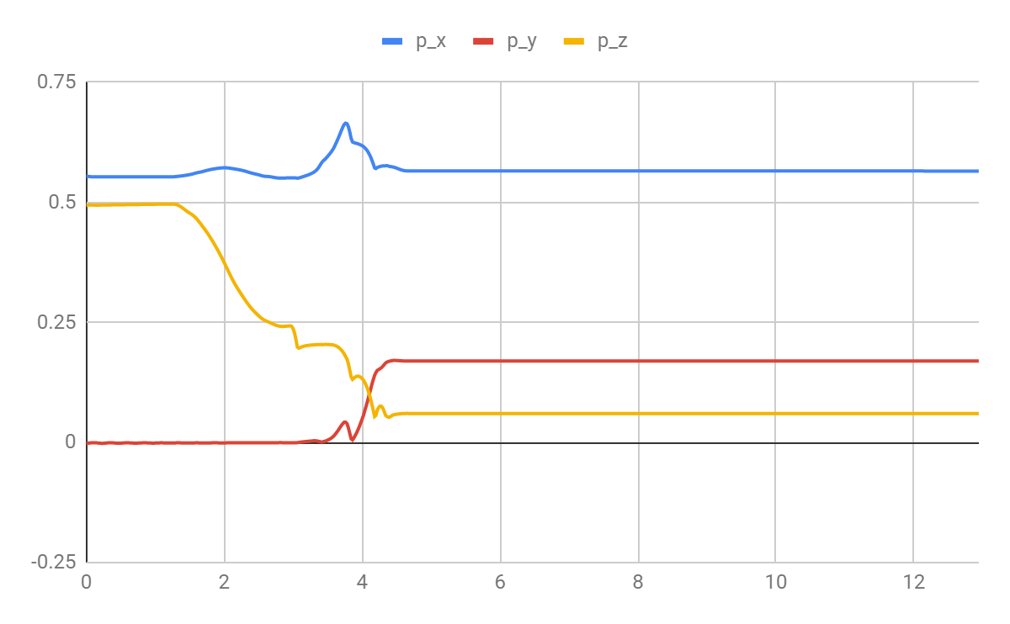

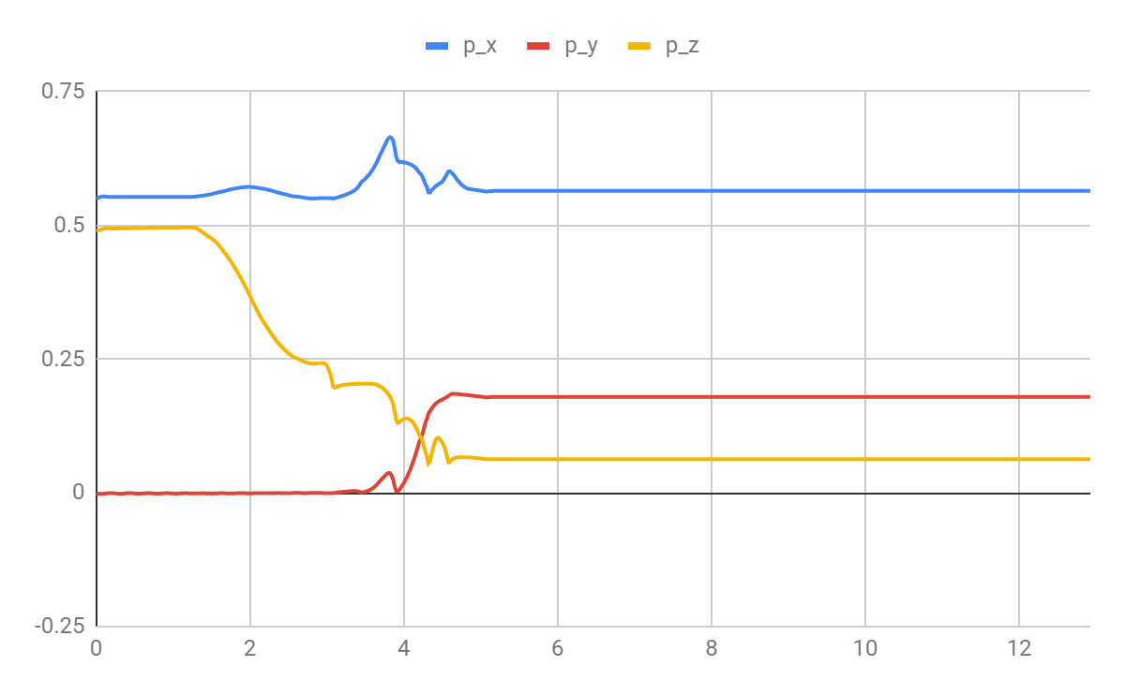

**FORCE V/S TIME FOR REAL ROBOT**

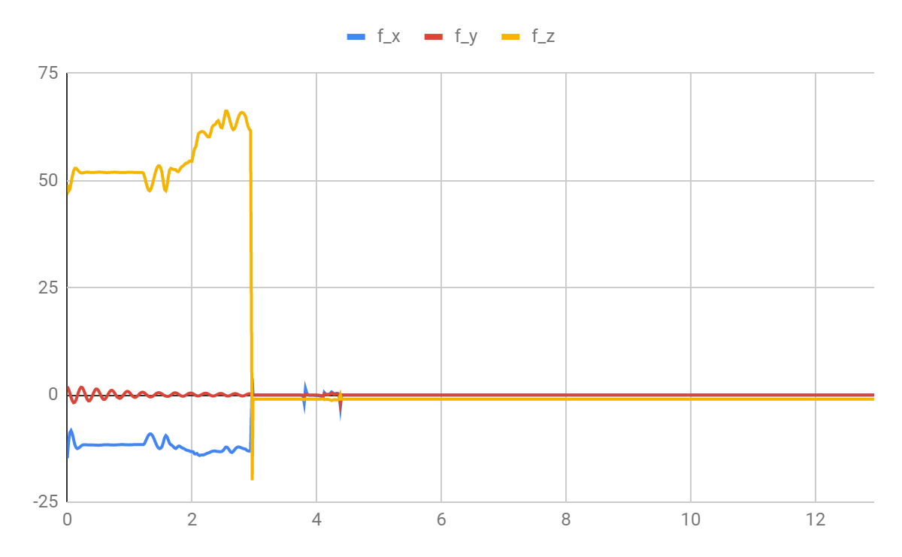

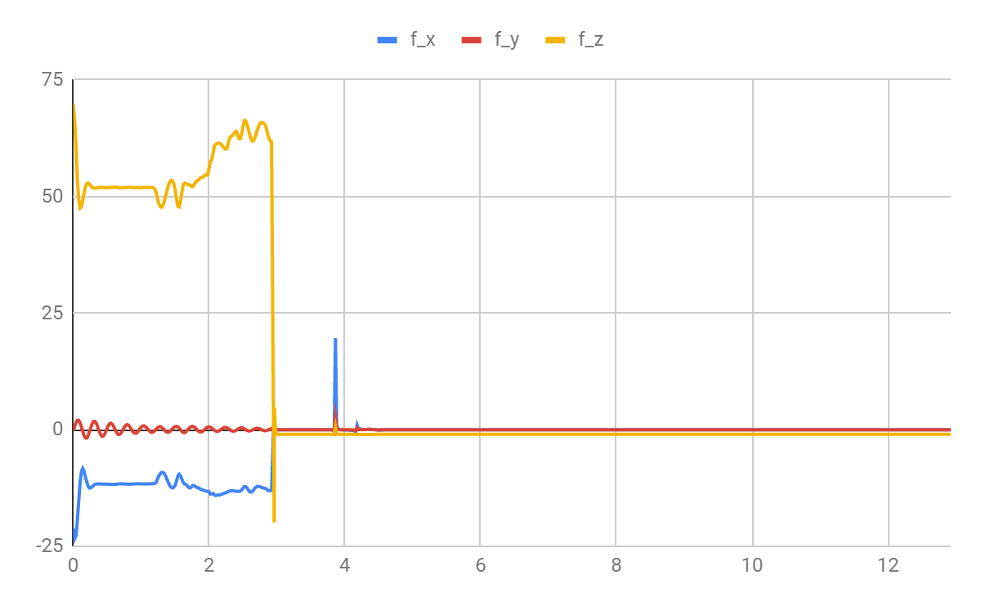

**Discussion of the results**

For the ideal robots the plots for feed forward and feedforward with feedback are more or less the same but however for the real robot, certain spikes are noticed in the force profile especially in f_x and p_x.

**Mathematical equations of Torque**





where

J is the Jacobian

Fd is the desired force

Kfp and Kfi are the proportional and integral constants

Fe = Fd –Ftip

**1) In which coordinate frame is the force/torque specified?**

Tool frame

**2) Is your force controller stable such that the robot remains in single stable robot configuration for a long time? If not, what technique can be used to stabilise it?**

The force controller stable is not stable because the robot fell after certain time. Tuning of the PID Controller can be used to stabilise.

**3) What is the benefit of the feedforward plus feedback-based controller compared to the feedforward only?**

Feedforward control is always used along with feedback control because a feedback control system is required to track set point changes and to suppress unmeasured disturbances that are always present in any real process. However, the decision as to whether or not to use feedforward control depends on whether the degree of improvement in the response to the measured disturbance justifies the added costs of implementation and maintenance. The economic benefits of feedforward control can come from lower operating costs.

**4) In which cases the integral term of feedback based controller is necessary?**

Integral term is necessary to reduce the steady state error in the process

**Estimation of time spent: - 12 hours** as I had problem with vdi.